TASK | Sealing surfaces to prevent oil leaks
LOCATION OF USE | Workshop |  | Assessment  No |  | 014
PRODUCT NAME | Loctite 5900 Flange Sealant
DESCRIPTION OF SUBSTANCE | Silicone Sealant
MANUFACTURER | Henkel
MANUFACTURERS CONTACT | Henkel Limited  Wood Lane End  Hemel Hempstead  HP2 4RQ  Great Britain  Phone: +44 1442278000  Emergency: 01442278497  ua-productsafety.uk@uk.henkel.com
ASSESSOR | Martin Monaghan CMIOSH |  | Date |  | 04 12 25
TITLE | Health and Safety Consultant |  | Review by |  | 04 12 27
Personnel Performing Task  (Please list below)  Technicians/ Fitters/ Workshop Operatives |  | Time Spent  (Minutes/day)  As and when required, amounting to a few minutes per day | Training Given 
 |  |  | Yes

MSDS Revision Date | Hazard Statement
07/04/2017 | H318 Causes serious eye damage  H317 May cause an allergic skin reaction  H351 Suspected of causing cancer

Assessment to be conducted in Association with Hazard Data Sheets, a full current copy of which must be attached to this assessment.

Please denote the hazardous properties of the substances used in the task with a 

NEW INTERNATIONAL GLOBALLY HARMONISED HAZARD SYMBOLS
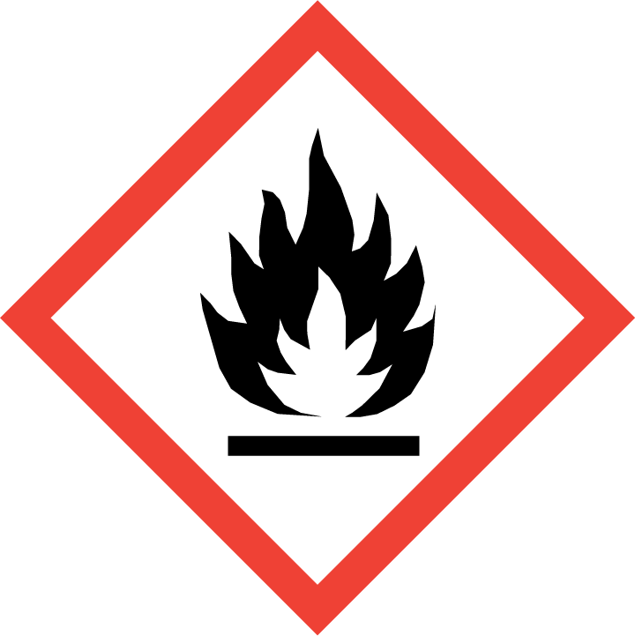 | 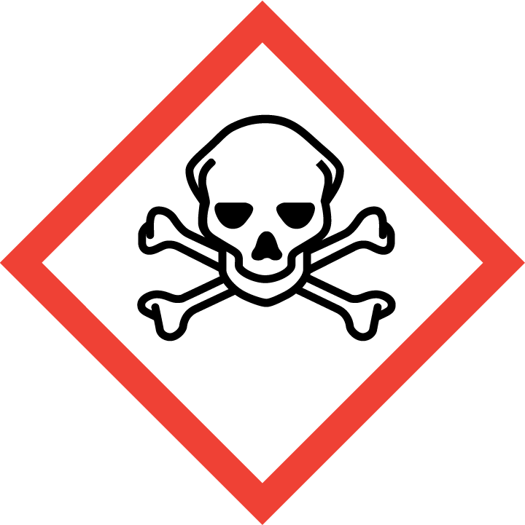 | 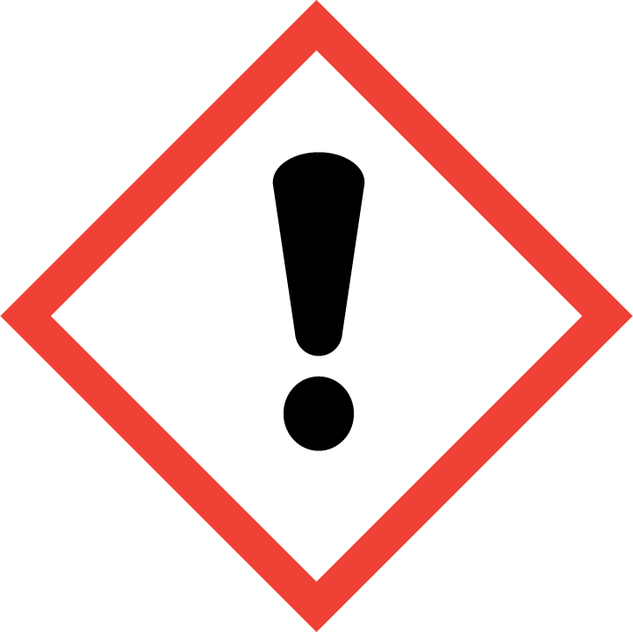 | 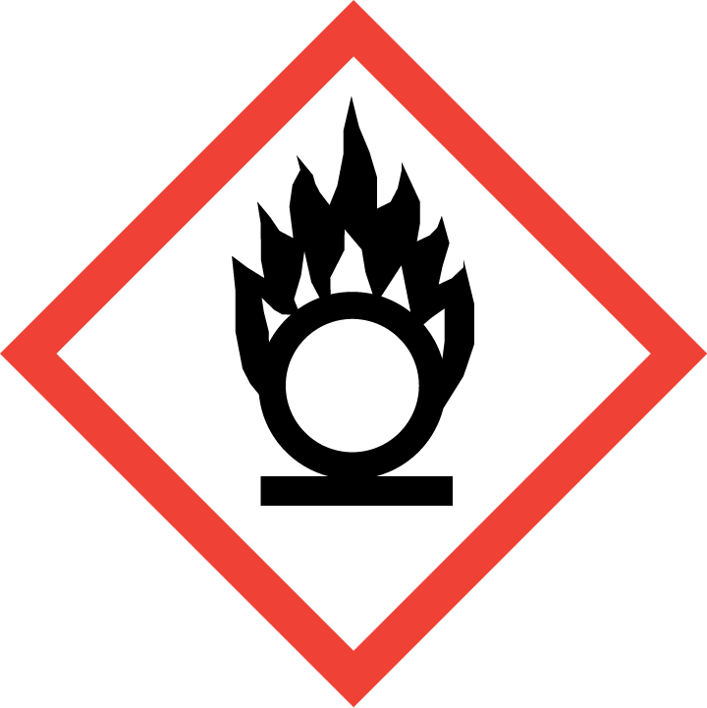 | 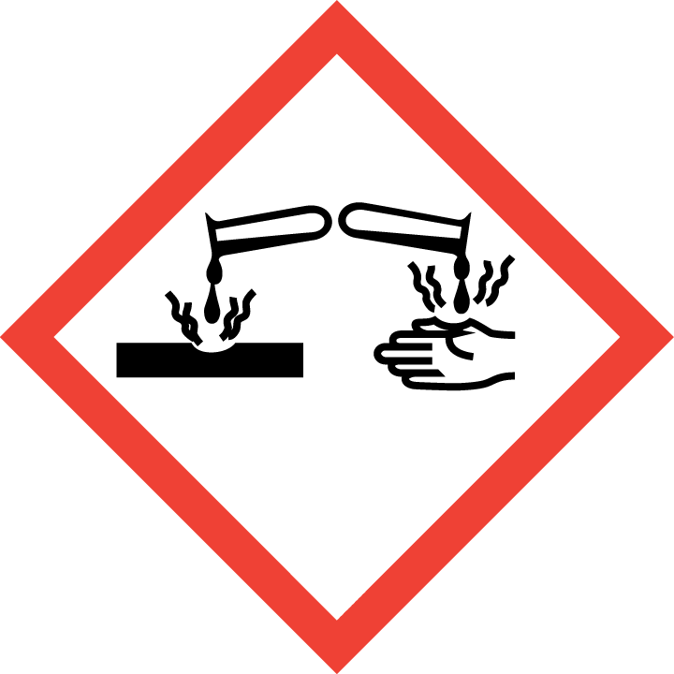 | 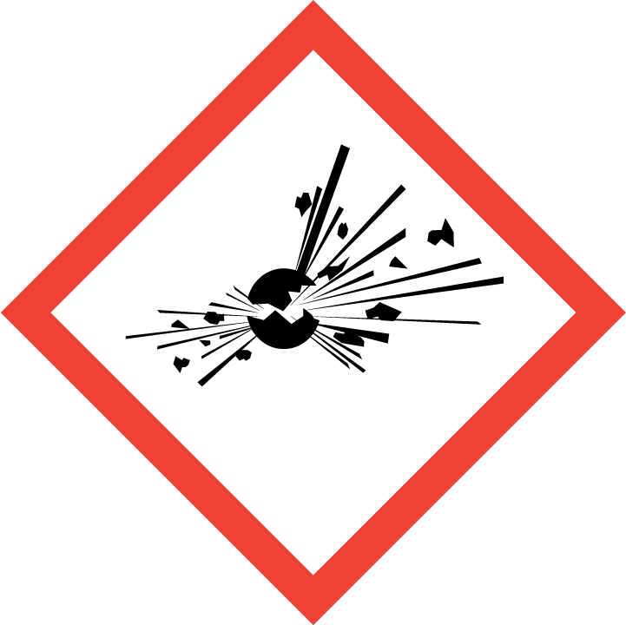 | 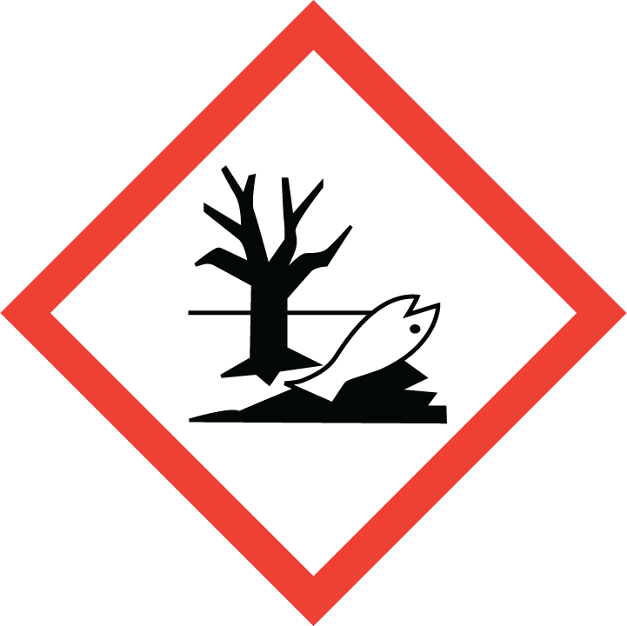 | 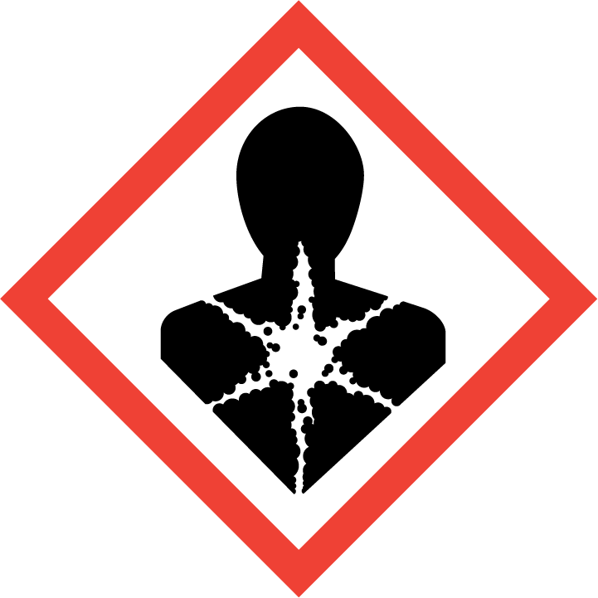
Flammable | Toxic | Harmful  Harmful in contact with skin | Oxidising | Corrosive | Explosive | Harmful to the environment | Health Hazards i.e. respiratory sensitisation or carcinogenicity Limited evidence of carcinogenic effect
 |  |  |  |  |  |  | 

SMOKING, EATING AND DRINKING ARE PROHIBITED IN THE WORK AREAS.
Information, Instruction and Training must be provided to all users. Young Persons, New or Expectant Mothers and other vulnerable groups must not use or be exposed to this product.

WORKPLACE EXPOSURE LIMITS (WEL’s)
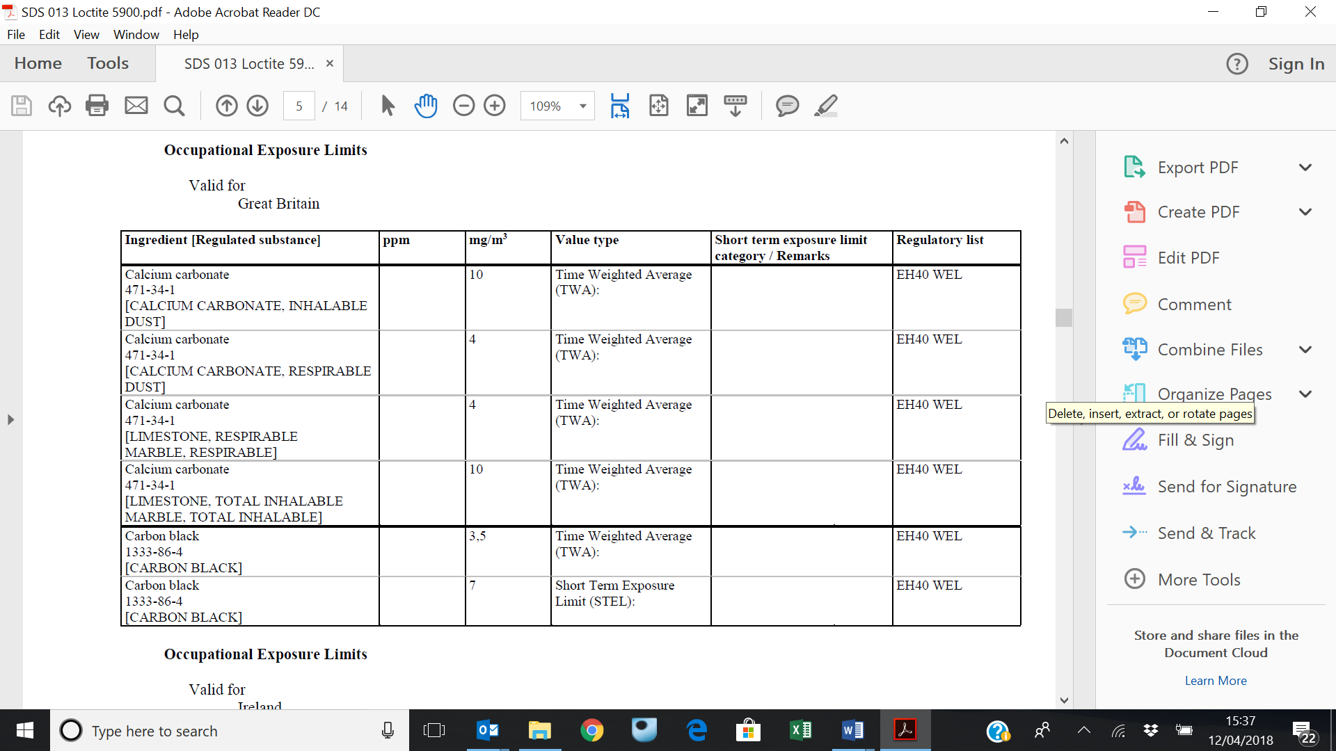

IMPORTANT!
Refer to Workplace Exposure Levels information provided in the Manufacturers Safety Data and revise control measures if exposure levels likely to be reached.

ROUTE OF EXPOSURE
Skin |  | Eyes |  | Inhalation | 
Ingestion |  | Cuts/abrasions |  | Systemic

PERSONS AT RISK
User of product |  | Co workers |  | Members of the public

ROUTE OF EXPOSURE |   FIRST AID MEASURES
Inhalation | Move to fresh air. If symptoms persist, seek medical advice.
Ingestion | Do not induce vomiting. Seek medical advice.
Skin contact | Wash with plenty of soap and water
Eye contact | Rinse immediately with plenty of water. Seek medical attention if necessary.
In all cases of doubt, or if symptoms persist seek medical attention. Never give anything by mouth to an unconscious person. If unconscious, place in recovery position and seek medical advice.

PERSONAL PROTECTIVE EQUIPMENT
 |  |  |  | 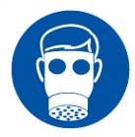 |  | 
YES | YES | YES/NO |  | YES/NO | YES | YES/NO
 |  |  |  |  | 
If splashing is likely wear EN166 safety glasses with side shields | Wear suitable protective clothing. |  |  | Must be worn if used in poorly ventilated area | Wear suitable protective gloves.

HANDLING | STORAGE | TRANSPORT | DISPOSAL
Use only in well ventilated areas. Do not breathe vapours. | Store in a cool, well-ventilated place.  Never allow product to get in contact with water during storage | Not hazardous | Product disposal:  Dispose of in accordance with local and national regulations.

REQUIRED CONTROL MEASURES
Avoid contact with skin and eyes, and inhalation of vapours/ spray or mist arising from the application of this preparation – Use PPE.
Only opened solvent containers should be kept at the bench.
When not in use, opened solvent containers should be kept in the flammables cupboards, under the work benches.
Surplus/ un-opened solvents must be kept in stores/ parts department.
Ensure adequate welfare and washing facilities available and provide users with barrier and restorative creams. Take good hygiene measures.
Ensure operatives are made aware of and understand the purpose of this assessment and SDS, plus any health implications of using the product.
Ensure COSHH assessments with accompanying SDS are made available for all employees and users and for inspection and emergency purpose.
Carry out personal exposure monitoring.
Good industrial hygiene practices should be observed. Wash hands before work breaks and after finishing work.

FIRE PRECAUTIONS
Extinguishing media: Carbon dioxide, foam, powder

Do not expose to direct heat, keep containers cool with water spray.

ACCIDENTAL RELEASE/SPILLAGE PROCEDURES
Scrape up as much material as possible.
Ensure adequate ventilation.
Store in a partly filled, closed container until disposal.
Wear protective equipment, avoid contact with eyes and skin.

MONITORING REQUIREMENTS AND HEALTH SURVEILLANCE
Health surveillance is not in place for workers exposed to this product.

